Brett Sutow

DSC 680

Boat Safety Analysis

***Introduction***

One of the fastest growing recreation for individuals is boating. Which in recent years has taken off to record levels. Specifically due to the COVID-19 crisis the purchasing of boats has reached levels we have never seen before. “Boat sales are expected to remain at historic levels in 2021 as manufacturers continue to fill a backlog of orders from 2020. Pandemic-related supply chain constraints curbed powerboat production and shipments for several months in 2020, which are expected to subside and restore marine manufacturing to normal levels this year” (NMMA). There are many different concepts of what boating actually is some consider it to be owning and operating a boat others consider it to include watersports as well as yachting. Due to this the boating industry as grown exponentially over the years. As COVID eliminated the ability to go on cruises as a source of vacation, individuals looked for other options. Whether that was charting a private yacht, buying a recreational boat, going on motorboat, or an even pontoon.

Few many years people have looked to boating as a popular way to spend the summer out on a lake or ocean. It has provided individuals many years of enjoyment and excitement whilst spending time out on the water. As water recreational vehicles have increased over the years, we have seen them become more affordable for those who enjoy the water. Which has lead to more people having the ability to add these vehicles to their collection. It seems boats have become more popular than those luxury items of the past like sports cars or chartering planes. "The run on boats is happening across the country. Chuck Cashman, the chief revenue officer of the boat dealership MarineMax, which has 64 locations in 23 states, says sales are up in every single category. Nearly three quarters of queries online are from first-time boat buyers, an unusually high number, he said"(Rubin, 2020).

However, with the desire and growth of boating we have seen an increased concern for the dangers. "The Florida Fish and Wildlife Conservation Commission released its 2020 boating accident statistical report which showed a 16 percent increase statewide in accidents and a 21.5 percent increase in the number of people who lost their lives in boating accidents" (Mayberg, 2021). Due to these concerns many are now rethinking boating as a safe recreational activity. This concern has specifically come out of the COVID-19 crises. As this has led to an increased number of first-time boaters and recreational water sport individuals. Which in turn means there are many people out on the water who are inexperienced. These numbers are increasing at a staggering rate.

In this study we are going to look at boating and water vehicle safety. We are going to investigate the changes over the years and using Python we are going to see the overall changes of this industry. As this industry grows, it becomes more important to ensure the safety of those individuals who are taking a break or holiday out on the water. The growth in the boating industry does not look to be stopping any time soon, as the COVID crises is beginning to wind down, and things are staying open we continue to see great demand for boating products. Through our research our overall goal is to prove the safety of the boating industry. Thus, proving that the boating industry is a safe, fun, and exciting recreational activity for all.

***Boat Safety***

As the boating industry grows, so does that of safety concerns. A few years ago the dangers of irresponsible boating came to the forefront when Miami Marlins star pitcher Jose Fernandez lost his life. "Jose Fernandez was driving his boat in a "reckless manner" when he died, investigators now say. And he had taken cocaine, toxicology reports already showed. And he had drunk alcohol — ordering two bottles of tequila — the nightclub verified" (Hyde, 2017). Whenever tragic events like this occur it brings into the limelight issues with not only the individual but, the thing they were doing. Many still bring up the fact that boating is a major cause for deaths in recreation. As boating has always been considered to be a quite dangerous hobby. Some even consider it to be up there with buying sports cars or motorcycles driving them at outrageous speeds.

However, the data speaks to a different story regarding boat safety. In fact when boating is done safely it can be fun, enjoyable, and harmless. The key word there, however, is safely. Many boating accidents, injuries and deaths are the cause of irresponsible actions of the driver. As what we saw with Jose Fernandez, many of these individuals believe they can drink, take risks, or even do drugs and still drive a boat. Whether it is driving impaired, too fast, or a combination of we see below that this is actually one of the major causes for boating deaths. As seen in the 2020 data graphic below.

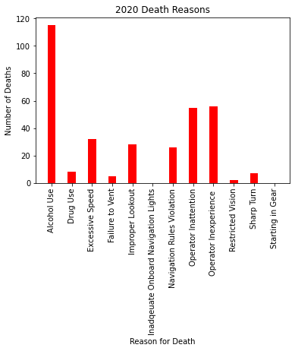

The opportunity for death increases significantly when the boaters are using alcohol. If you are looking for a fun day on the water, this should be avoided for the safety of all passengers. Drinking leads to the bigger possibility of death. These statistics include all boat types that can have a driver as well as passengers. However, once this is taken into consideration, we can greatly improve safety. Looking more into the data for 2020 we can see an increase in accidents largely due to mistakes by the user. As stated earlier in this paper, 2020 was a booming year for boating. Many first-time boat buyers came into frame due to the COVID-19 crises and do to this we saw increased accident numbers. These numbers were largely based off inexperience and captain mistakes.

Seen above a major cause of the 2020 accidents came in the form of those individuals who were inexperience. Whether this was in the form of driver error, inattention, mistakes, or even improper lookouts on boats. Many of which could be easily avoided. These reasons caused a staggering increase in boating accidents and deaths for the 2020 season. However, comparably these statistics were on the decline. As we have seen increased safety regulations over the years, boating has become a innocent form of entertainment. The data below will show the decrease in boating accidents and injuries over the years until the increase in the 2020 season.

**Legend: Green is Accidents, Purple is Injuries, Gold is Deaths**

This data proves the fact that boating has actually become more increasingly safe. However, due to the rarity of major accidents or deaths they are more highly talked about on news stations. Especially when that includes a well known celebrity or athlete. When this is the case we see more criticism on what the data states is a relatively safe recreational activity. The data speaks volumes that the only major danger with boating is the increased number of those who are inexperienced. Which over time should improve greatly.

***Other Water Vehicle Safety***

Besides boating there are other water recreation activities out there. Many consider things like jet skis, water motor vehicles, or other water recreational objects. These objects are however much more dangerous than that of boats. As typically these are not run by experienced individuals or those who do it professionally. Instead we see many individuals who are trying to find enjoyment creating more issues. This became specifically apparent during the 1990s when popularity soared for these items. Which caused an influx of inexperienced individuals out on the water. As see in the number of deaths in the visual below.

Since the 1990s we have seen significant improvements in this area, with new laws and regulations coming into play. Along with this in general personal watercrafts became safer overall as manufacturers implemented new protocols. Over the years we have seen a decrease in deaths, accidents, and injuries from these watercraft vehicles. Only to see a major rise again in the 2020 year. Due to increased sales and increased number of these vehicles out on the water. Due to this, the dangers have increased significantly for these objects. However, once again if done correctly watercrafts can be very safe.

***Results***

In this study we took a look a two different water vehicle types we looked at what would be classified as boats and those that would be seen as water sport entertainment. This study showed that we have overall seen a significant increase in deaths, injuries, and accidents across the board in the year 2020. However, with that being said we know through various resources, data points, and information that this was a cause of significant inexperience out on the water. "But at the same time that the sale of yachts and power boats have soared, there has been a spike in boating accidents on the ocean, rivers, lakes and ponds, resulting in injuries and deaths, say public safety officials, who attribute the uptick in accidents to more boat traffic and inexperienced boaters" (Brown, 2020).

Inexperience and irresponsibility are the main reasons we see these dangers in boating. When done correctly and properly these water activities are in fact very safe. As studies have support and this data points discussed in this paper show. We were in fact on a downward swing in boating dangers until 2020. Due to the rarity of accidents and deaths out on the water they are often spoken about more frequently on news stations when one occurs. Overall, boating is safe as long as you have proper training, or paired with an experience captain.

***Appendix***

*Please also reference attached code notebook and pdf for more details. Find below graphs, charts, and other important information regarding this study. These are just the basis of which the study was built upon. The attached notebook will provide more information.*

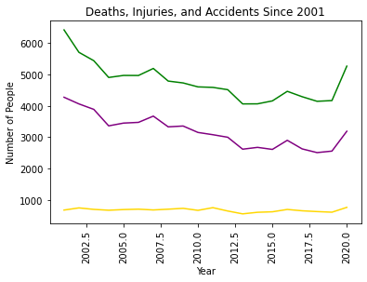

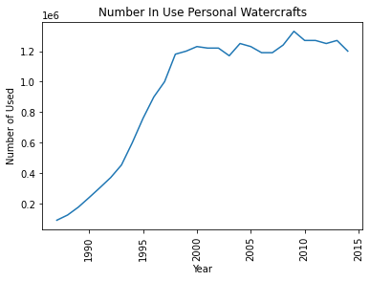

**

***References***

Curt Brown, The Herald News. (2020, July 26). *The perfect storm: Lots of boats, lots of inexperience, lots of accidents*. The Herald News. <https://eu.heraldnews.com/story/news/accident/2020/07/26/perfect-storm-lots-of-boats-lots-of-inexperience-lots-of-accidents/42908611/>

Hyde, D. (2017, March 17). *Sun Sentinel*. Sun Sentinel. <https://www.tribpub.com/gdpr/sun-sentinel.com/>

MAYBERG. (2021, May 14). *Boating accidents increase statewide; Lee ranked fifth*. Captivasanibel.Com/. <https://www.captivasanibel.com/2021/05/14/boating-accidents-increase-statewide-lee-ranked-fifth/#:%7E:text=The%20Florida%20Fish%20and%20Wildlife,their%20lives%20in%20boating%20accidents>.

*Personal Watercraft Safety Data*. (2020). Bureau of Transportation Statistics. <https://www.bts.gov/content/personal-watercraft-safety-data>

Rubin, C. (2020, July 2). *The Boat Business Is Booming*. The New York Times. <https://www.nytimes.com/2020/07/02/style/boat-sales-summer.html>

*Safe Boating Tips*. (n.d.). Discover Boating. Retrieved July 29, 2021, from <https://www.discoverboating.com/ownership/safety/tips>

Sullivan, S. (2019, January 16). *Are Boats Safer Than Airplanes & Cars? (Helpful Facts)*. Godownsize. <https://www.godownsize.com/boat-safety-compared-airplanes-cars/#:%7E:text=Are%20Boats%20Safer%20Than%20Airplanes%20And%20Cars%3F,road%20accidents%20per%20year%20globally>.

*Three of the Most Dangerous Boating Conditions*. (n.d.). Travelers Insurance. Retrieved July 29, 2021, from <https://www.travelers.com/resources/boating/three-of-the-most-dangerous-boating-conditions>

*U.S. Boat Sales Reached 13-Year High in 2020, Recreational Boating Boom to Continue through 2021*. (2021, January 6). Nmma. <https://www.nmma.org/press/article/23527>

*uscgboating*. (2020). Uscgboating. https://www.uscgboating.org/library/accident-statistics/Recreational-Boating-Statistics-2020.pdf

***Ten Questions:***

1. ***Do you believe boating is safe?***
2. ***What is the difference between cruises, yachts, and personal boats?***
3. ***Should you use an experience captain?***
4. ***What are the major causes of accidents?***
5. ***Should individuals be allowed to own boats?***
6. ***Difference between boats and watercrafts?***
7. ***Who is to blame for accidents?***
8. ***Do you have concerns about increased growth in the market?***
9. ***How do boats compare to other recreational motor vehicles?***
10. ***Why are boating deaths so highly covered?***